**Infrastructure Architecture and Design**

* + There are several expectations about the quality of service of the application - consistent user experience, enterprise data security, ability to handle vast online user base, 24/7 availability and disaster recovery to ensure business continuity.
  + Infrastructure architecture ensures that these capabilities are planned for, and built into the system.

**Infrastructure Architecture Building Blocks**

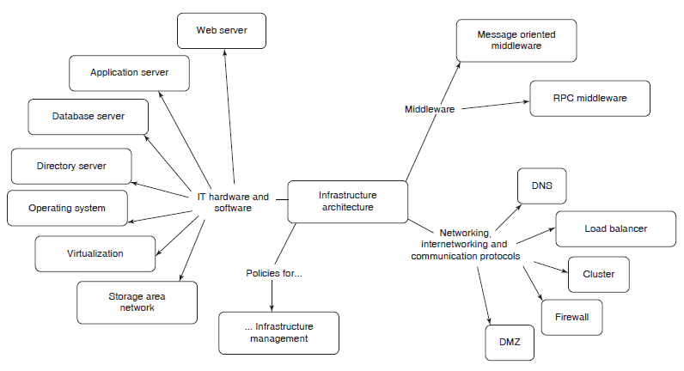

**Networking, Internetworking and Communication Protocols**

* + The connectivity across all the locations and devices is supported by the ‘networking, internetworking and communication protocols’ building block of the infrastructure architecture.
  + A few of the key elements:
  + **DNS:** An Internet or intranet enterprise application is accessed via a URL (Uniform Resource Locator), which is mapped to a specific IP address. This mapping is provided by a Domain Name Server (DNS).
  + **Load Balancer:** Available both as hardware and software, helps in splitting the traffic to ensure the scalability of an enterprise application.

**Networking, Internetworking and Communication Protocols (Contd…)**

* + **Cluster:** Helps to ensure the availability and performance of an enterprise application.
  + **Firewall:** Used to achieve the security at the network level.
  + **DMZ (Demilitarized Zone):** Also known as perimeter network, is a sub network of an organization, which provides access to the external facing services of an enterprise to the outside world.

**IT Hardware and Software**

* + IT Hardware and Software is the core building block of infrastructure architecture, which comprises of several elements such as operating systems, servers, storage mechanisms, communication mechanisms and application platforms.
  + A few key elements in this building block are:
  + **Operating System:** provides a complete set of facilities to manage the hardware and software resources.
  + **Database Servers:** Provides data related services such as efficient storage, search and retrieval, data integrity, security and transaction support.

**IT Hardware and Software (Contd…)**

* + **Web Server:** The server which accepts HTTP/HTTPS requests from a browser, and services them by interacting with other tiers.
  + **Application servers:** The core business logic of an application is hosted on an application server.
  + **Virtualization:** mechanism to abstract IT infrastructure. It can be viewed as a design pattern in the IT infrastructure landscape, and is implemented at different levels like platform or system resource level.

**Middleware**

* + Middleware is the software glue which binds together the software pieces of a distributed application, and enables integration of discrete enterprise applications and their components.
  + It is used to enable interoperability and enhance reliability of applications.

**Middleware (Contd…)**

* + Middleware can be categorized into the following types:
  + **Message Oriented Middleware (MOM):** based on a client/server architecture and is used for reliable transport of messages across heterogeneous, geographically distributed systems.
  + **Remote Procedure Call (RPC):** provides a mechanism for invocation of procedures on a remote server in a way identical to invocation of local procedures, by completely hiding the details of the underlying network.

**Deployment Strategy**

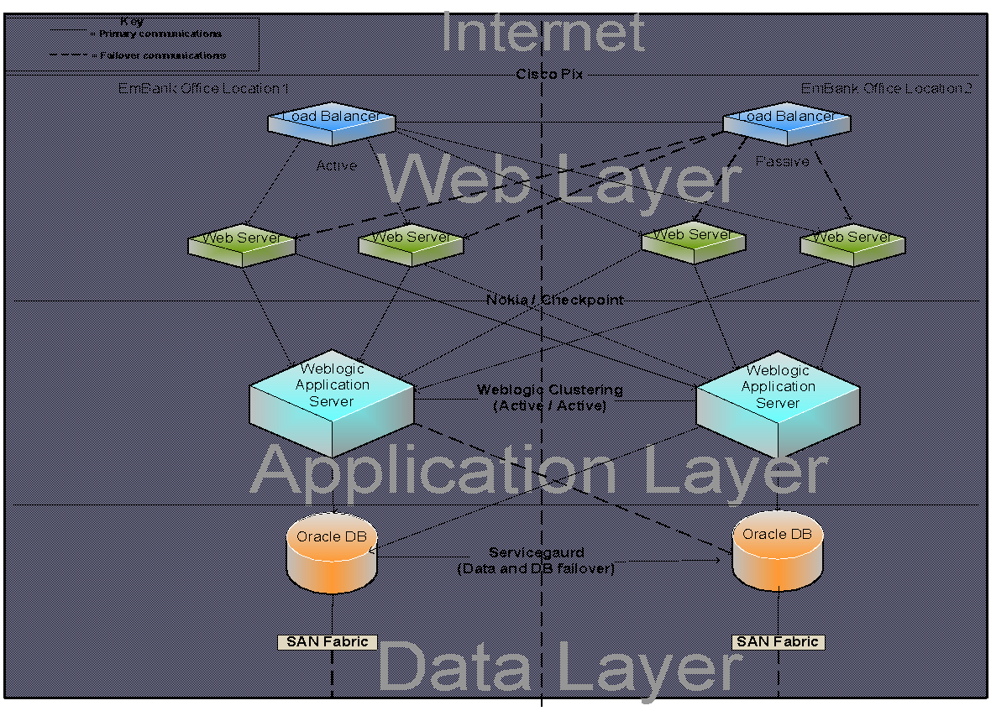

**Architecture and Design Documentation**

* + The architecture of an enterprise application is documented in the System Architecture Document (SAD).
  + The term high level design is also used interchangeably with SAD.
  + It acts as a blueprint for the detailed design process.
  + The detailed design of an enterprise application can be documented in several ways - technical layer wise, module/use case wise, component wise, or typically a mix of them.
  + The overall objective of the design documentation is effective communication among application teams which are involved in design, development and deployment activities.
  + The design documentation should include, for each use case, the presentation, business and data access components.
  + In addition to this, integration and database designs may be documented separately.

**Key Elements of SAD**

|  |  |
| --- | --- |
| **SAD Element** | **Description** |
| Goals of the architecture | principles |
| Solution constraints | Constraints to be met in the architecture |
| Logical Architecture | Logical representation of all layers |
| Quality of services | NFRs |
| Interface/ integration requirements | Information about external systems |
| Technology selection | Tools, technologies, frameworks |
| Technical architecture | Technical solution |
| Data architecture | Business entities and relationships |
| Infrastructure architecture | h/w, s/w, middleware, network topologies |

**Key Elements of Presentation Layer Design Document**

|  |  |
| --- | --- |
| **SAD Element** | **Description** |
| Screen mockups | Wireframes, UI layout, screen templates and event handling |
| Error handling | Recovery actions in the event of errors and messages |
| Input validation | Rules for validating user input data on both client and server side |

**Key Elements of Business and data access layer Design Document**

|  |  |
| --- | --- |
| **SAD Element** | **Description** |
| Business delegate | Captures set of methods that need to be invoked |
| Session façade | Captures the list of services that need to be grouped |
| Business service | This captures the business interfaces and their implementation details |
| Business Model | This captures the business entities and their interrelationships |
| Data Access Layer components | This includes the design details of data access components, object relational mappings etc. |